LIP TATTOO AFTERCARE

Proper care following your semi-permanent lip tattooing is necessary to achieve the best results.

You may experience the following symptoms for 4 days after lip tattoo treatment

* Swelling and redness.
* Tenderness.
* Flaking and mild itchiness as the lips heal.
* Dry skin may remain for up to 2 weeks.
* These symptoms are a normal part of the healing process.

Immediately after

Drink fluids immediately after the treatment using a straw to keep hydrated.

Cold packs may be applied as necessary to reduce any swelling (do not apply directly on lips, wrap with tissue).

Daily Care to follow for 7 days

Apply the healing balm regularly using a cotton bud or clean freshly washed hands. Washing your hands before applying the product will prevent cross-contamination of the product and also not replacing the used bud into the container.

It is recommended that you use a gentle facial cleanser to freshen your skin during the first week rather than washing your face, which could potentially wet the lip area. Do not splash wash your face.

Apply a layer of Vaseline to your semi-permanent lips when brushing your teeth to prevent it from becoming wet. Remove the Vaseline with damp cotton pads using sterile water (boiled, cooled water).

If your lip tattoo gets wet, gently pat the area dry using a clean tissue.

Some itching is normal. DO NOT PICK, PEEL OR RUB your lips as the colour may heal unevenly and you could risk infection, which in turn could lead to scarring.

Allow the colour to flake away by itself.

No make-up should be applied close to your lip area for 3 days.

Avoid eating spicy and salty foods and drink through a straw for 3 days.

Avoid alcohol for 24-48hrs.

No kissing for 5 days to prevent infection.

Do not receive skincare beauty treatments for 5 days after the application of your lip tattoo.

Avoid For 2 Weeks

Do not expose your lips to direct sun, tanning treatments, Jacuzzis, saunas, saltwater, chlorinated pools and direct shower spray.

Do not receive bleaching, waxing, electrolysis or laser hair removal treatments close to your lips.

Do not use lip plump products.

Do not receive lip filler treatments.

Important Notes

If you suffer from cold sores at present or anytime in the past use an anti-herpes medication 5 times daily for 1 week. If an outbreak does occur it will generally begin on day 3 of the healing process.

Remember, your selected colour will be stronger and more sharply defined for 4 – 5 days and will then shed away appearing as if little or no colour is present. Over the next 3 weeks, the colour will blossom into a considerably softer version of the original colour.

The approximate healing period is 14 days, however, healing can be prolonged if your immune system is compromised if you are generally stressed and by poor diet.

Keep in mind that in many cases, some unevenness of colour is to be expected. This is the purpose of the top-up visit allowing us to fine-tune your lip tattoo.

Long Term Care

Use a good sunscreen. Sun exposure will fade your micro-pigmentation enhancement. If you are planning a chemical peel, laser or IPL on your face or an MRI scan, please inform the technician of your micro-pigmentation enhancement.

Please inform the National Blood Service if you donate blood, as you may not be eligible to give blood for 4 months post-application.

Stages of healing

The colour will be darker straight after the treatment and may go darker the next day, as the pigment oxidises in the skin.

Once healed, the pigment may look like it has disappeared or ‘not worked’ DON’T WORRY – this is completely normal and part of the healing process. Your skin is healing on the inside and the colour will bloom back. This can take up to 4 weeks.

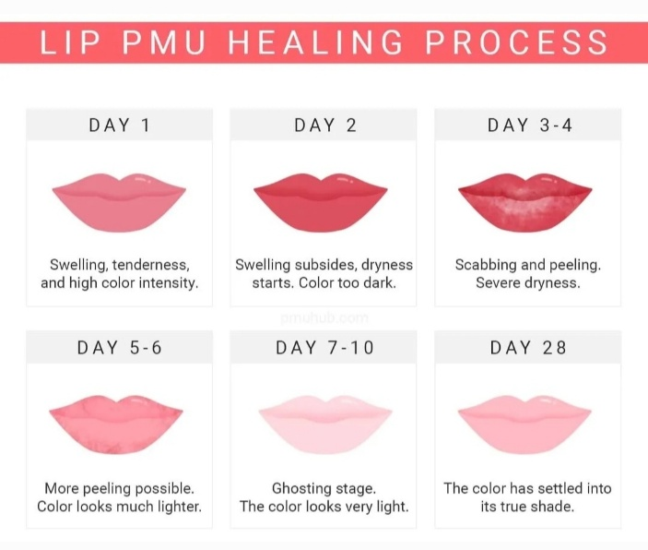For cosmetic treatments, a second appointment is needed 4-6 weeks after your first treatment. This is usually a 1.5-2hr appointment to add more pigment. This is because as the area is healing, some parts may not ‘hold’ as well as others and you may have a few patches that need more colour. This is completely normal and everyone heals differently.